**Line graphs**

A line graph, also known as a line chart, is a type of chart used to visualize the value of something over time. For example, a manufacturer, who manufactures product X may plot the number of product sold over time to analyze the trend. The line graph consists of a horizontal x-axis and a vertical y-axis.

**Visualization with line graph**

For this we have to follow some steps :

* Open Tableau tool and connect a dataset into it.
* Drag and drop the one sheet of the connected dataset.
* Click on Sheet1 (at the bottom) to open the tableau worksheet.
* On clicking Sheet1 you will get whole dataset attributes on the left side and a worksheet for work.

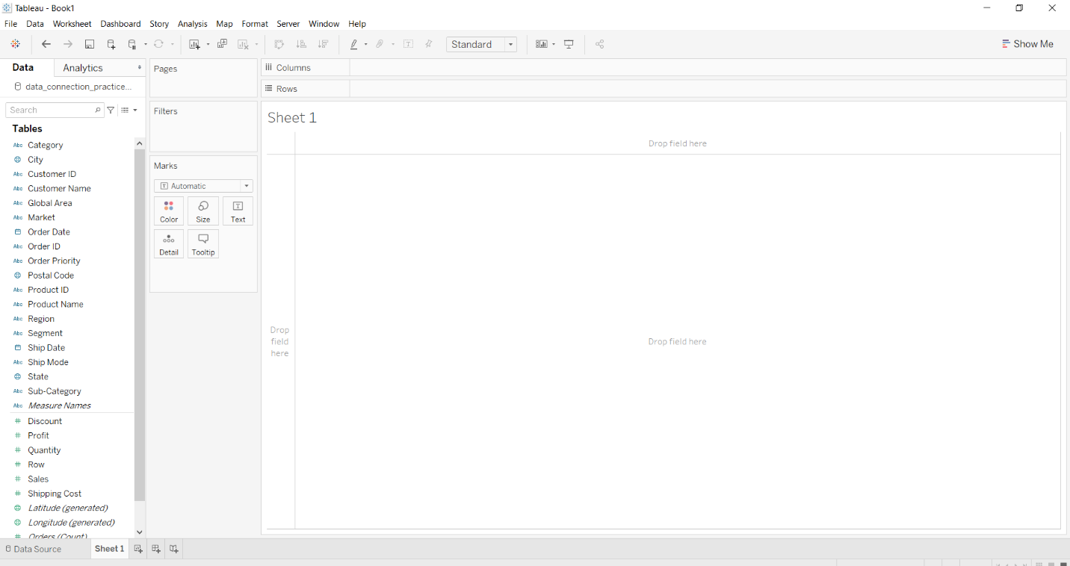

* To draw a line graph you have to select a minimum of two attributes( one in a row and one in a column) by dragging and dropping. Then select the chart option as a line.

**Example 1:**



**Example 2:**

* Select the Region and Sales fields as column and row respectively.
* Select the chart type line graph.
* Drag and drop the subcategory field in **Marks section,**choose **color**( by clicking three dots near it) to apply different color that makes it easier to distinguish between different subcategories.

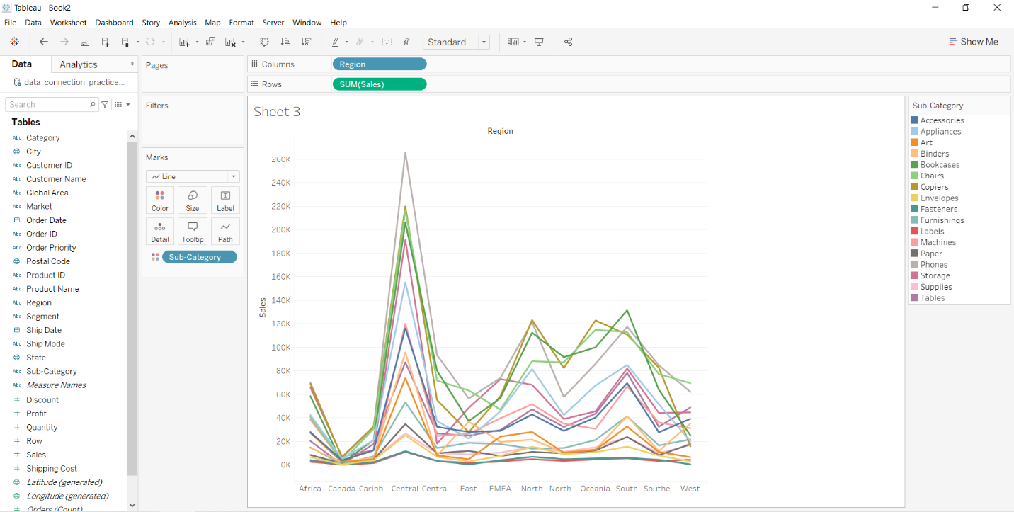

**Example 3:**

* Select the Category with Subcategory and sum as column and rows respectively.
* Select the chart type line graph.
* Drag and drop the market field in color to apply the marks that make it easier to distinguish between different markets.
* Click on the color and choose the marker type as a dot on lines for a better view.

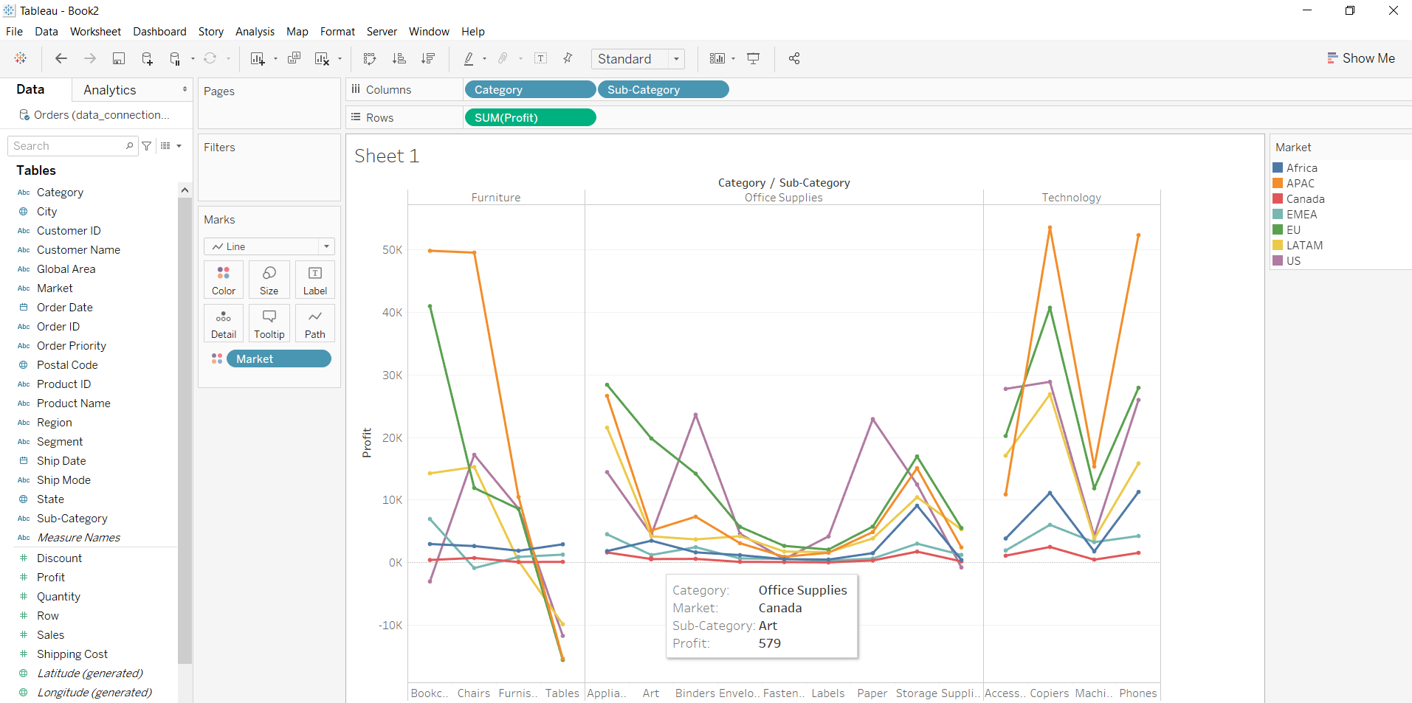

**Example 4:**

* Select the Region and Category, Sales as column and rows respectively.
* Select the chart type line graph.
* Drag and drop the discount field in color to apply the marks that make it easier to distinguish between values of discount.
* Drag and drop the profit field in the label to apply the marks that make it easier to view the profit value.

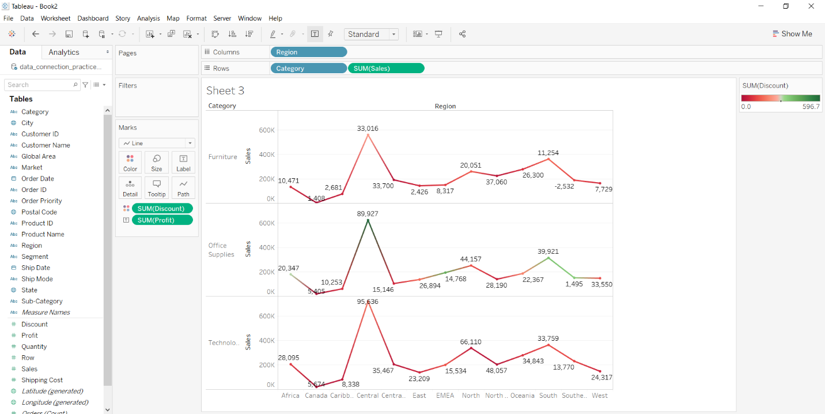

**Dual Lines Chart:**Line charts connect individual data points in a view. They provide a simple way to visualize a sequence of values and are useful when you want to see trends over time, or to forecast future values.

For this we have to follow some steps :

Open the Tableau tool and connect a dataset to it. Drag and drop the one sheet of the connected dataset. Click on sheet1 to open the tableau worksheet. On clicking Sheet1 you will get whole dataset attributes on the left side and a worksheet for work.



To draw a dual lines chart you have to select minimum of three attributes by drag and drop into a row then apply the other parameter for better visualization.

**Example 1:**In this example, we simply draw a dual lines chart by using the show me option.



**Example 2:**This example uses above example 1 with some extra marks (apply the label and color marks) and which are shown easily below :



**Example 3:**This example uses above example 1 with some extra marks (apply the label and color marks) then apply forecast analytics and which are shown easily below :



**Bar Chart :**It is a graph that displays categorical data with rectangular bars with heights that are equivalent to the amounts they depict. The bars can be displayed vertically or horizontally. A vertical bar map is often referred to as the column map.

**Below are the steps to illustrate data in the form of a Bar chart in Tableau:**

**1)**Open Tableau tool and connect a dataset into it.

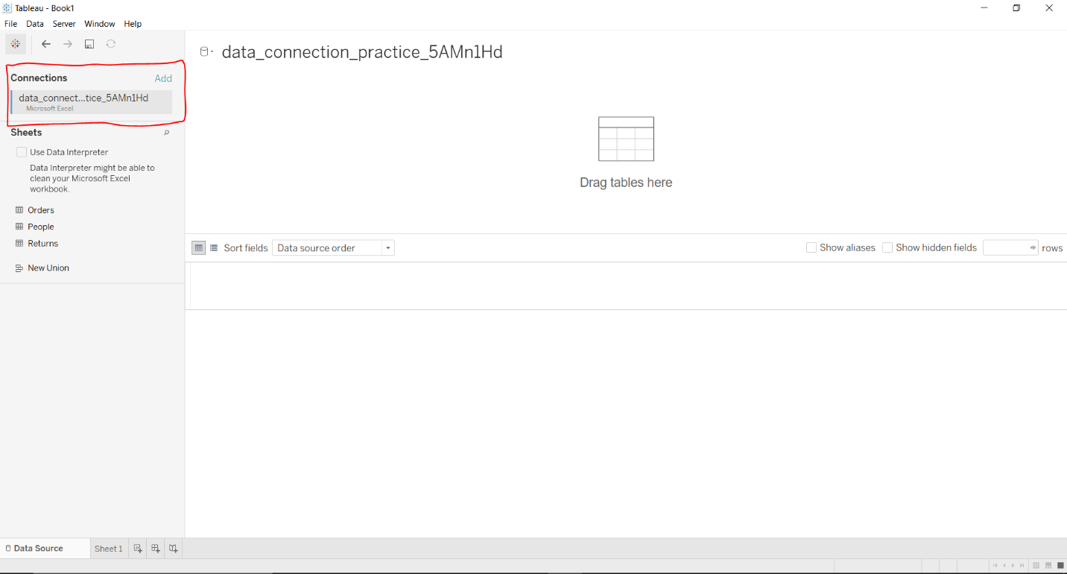

**2)**Drag and drop the one sheet of connected dataset.



**3)**Click on sheet1 to open the tableau worksheet.

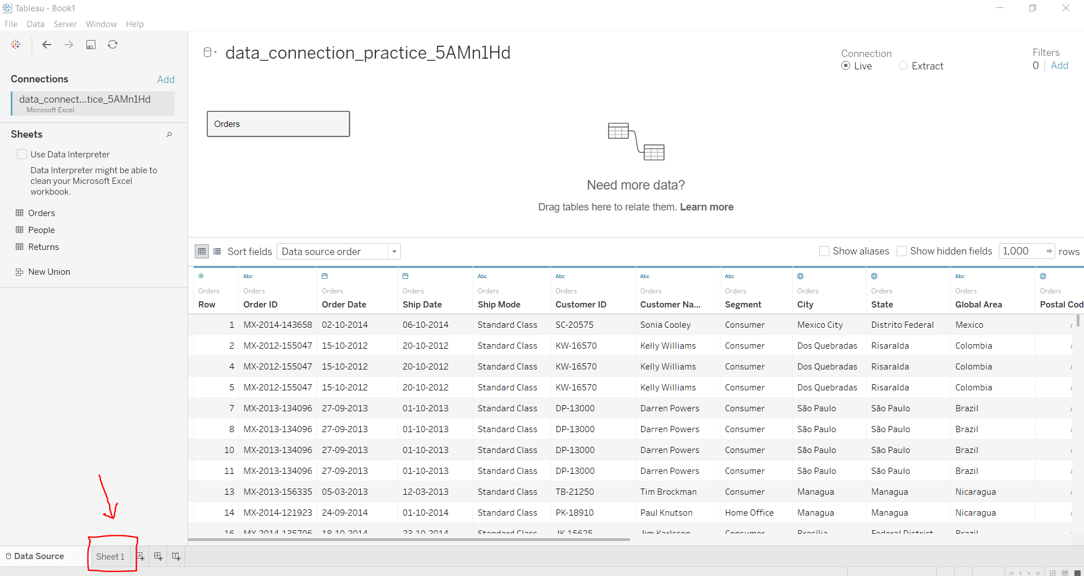

**4)**On clicking Sheet1 you will get whole dataset attributes on left side and a worksheet for work.



**5)**To draw a bar chart you have to select minimum two attributes( one in row and one in column) by drag and drop then select the chart option as bar.



**Below are some examples of the above approach:**

**Example 1:**

This example is also drawn similar to the above steps with some extra marks and which is explained in steps given below:

* Select the Date (dimension must be like year, month, etc ) and Sales with profit fields as column and rows respectively.
* Select the chart type bar chart.

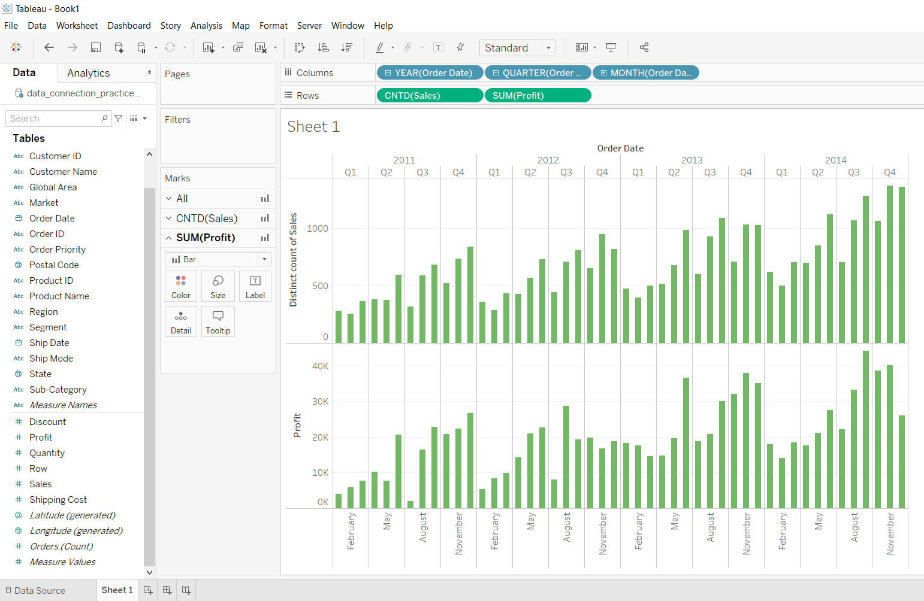

**Example 3:**

This example is also drawn similar to above example 2 with some extra marks and which is explained in steps given below:

* Select the Region and Sales with profit fields as row and columns respectively.
* Select the chart type bar chart.
* Apply marks by color of discount.
* Apply filter by sum of quantity.

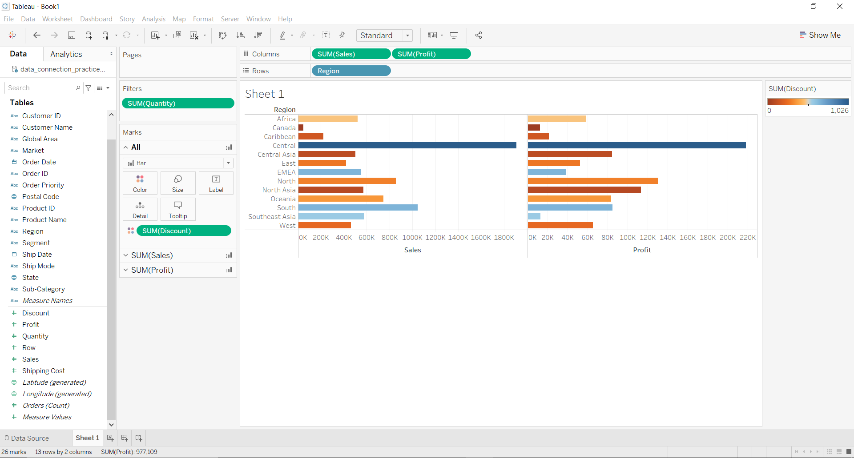

**Side-by-side bar graph**

In a side-by side bar chart, the bars are split into colored bar segment. In a stacked bar graph, the bar segments within a category bar are placed on top of the other, and in a side-by-side bar graph, they are placed next to every other field chosen

Steps to import dataset:

1. Open Tableau tool and connect a dataset into it.
2. Drag and drop the one sheet of the connected dataset.
3. Click on sheet1 to open the tableau worksheet.
4. On clicking Sheet1 you will get whole dataset attributes on the left side and a worksheet for work.



To draw a side by side bar graph you have to select minimum three attributes( two in row and one in column) by drag and drop then select the chart option as side by side bar graph.

**Example 1:**

* Drag and drop the fields in rows and columns.
* Choose the chart as side by side bar graph.



**Example 2:**

* Drag and drop the fields in rows and columns.
* Choose the chart as side by side bar graph.
* Change the colors by choosing a new palette.
* Apply the border marks of black color.



**Example 3:**

In this example, we use example 2 with some enhancements that are listed below :

* Drag and drop the fields in rows and columns.
* Choose the chart as side by side bar graph.
* Change the colors by choosing a new palette.
* Apply the border marks of black color.
* Apply the label marks by drag and drop of fields.
* Arrange the column field in ascending and then in descending order.
* Apply quick table calculation of profit on a field.



**Stacked bars**

The stacked bars are nothing but, the bar charts with segments inside. These internal segments add detail to the fields marked as bars and are differentiated by colors. It is mostly used to compare categorical data.

For this, we have to import the dataset first. Follow the steps :

1. Open Tableau tool and connect a dataset into it.
2. Drag and drop the one sheet of connected dataset.
3. Click on sheet1 to open the tableau worksheet.
4. On clicking Sheet1 you will get whole dataset attributes on left side and a worksheet for work.



To draw a stacked bar graph you have to select minimum three attributes( one in row and two in column) by dragging and dropping then select the chart option as stacked bar graph.

**Example 1:**

You can use the following steps to draw a stacked bar graph.

* Drag and drop the fields in rows and columns.
* Choose the chart as stacked bar graph.



**Example 2:**

* Drag and drop the fields in rows and  columns.
* Choose the chart as stacked bar graph.
* Change the color by choosing a new palette.
* Apply the border marks.



**Example 3:**

* Drag and drop the multiple fields in rows and columns.
* Choose the chart as a stacked bar graph.

**Histogram:** A histogram contains a rectangular area to display the statistical information which is proportional to the frequency of a variable and its width in successive numerical intervals. A graphical representation that manages a group of data points into different specified ranges. It has a special feature that shows no gaps between the bars and similar to a vertical bar graph.

For this we have to follow some steps :

Open the Tableau tool and connect a dataset into it. Drag and drop the one sheet of the connected dataset. Click on sheet1 to open the tableau worksheet. On clicking Sheet1 you will get whole dataset attributes on the left side and a worksheet for work.



To draw a histogram you have to select a minimum one attribute by drag and drop then select the chart option as a histogram.

**Example 1:**



**Example 2:**This example is also drawn similar to above example 1 with some extra marks and which is explained in steps given below:

* Select the discount as column and row.
* Select the chart type histogram.
* Apply marks by color of market.

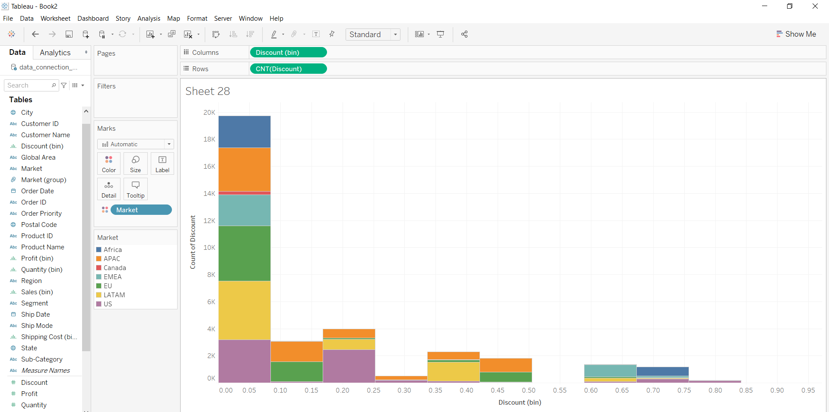

**Example 3:**This example is also drawn similar to above example 1 with some extra marks and which is explained in steps given below:

* Select the Discount as column and row.
* Select the chart type histogram.
* Select the profit field in row
* Apply marks by color of region.
* Apply marks by text of market.

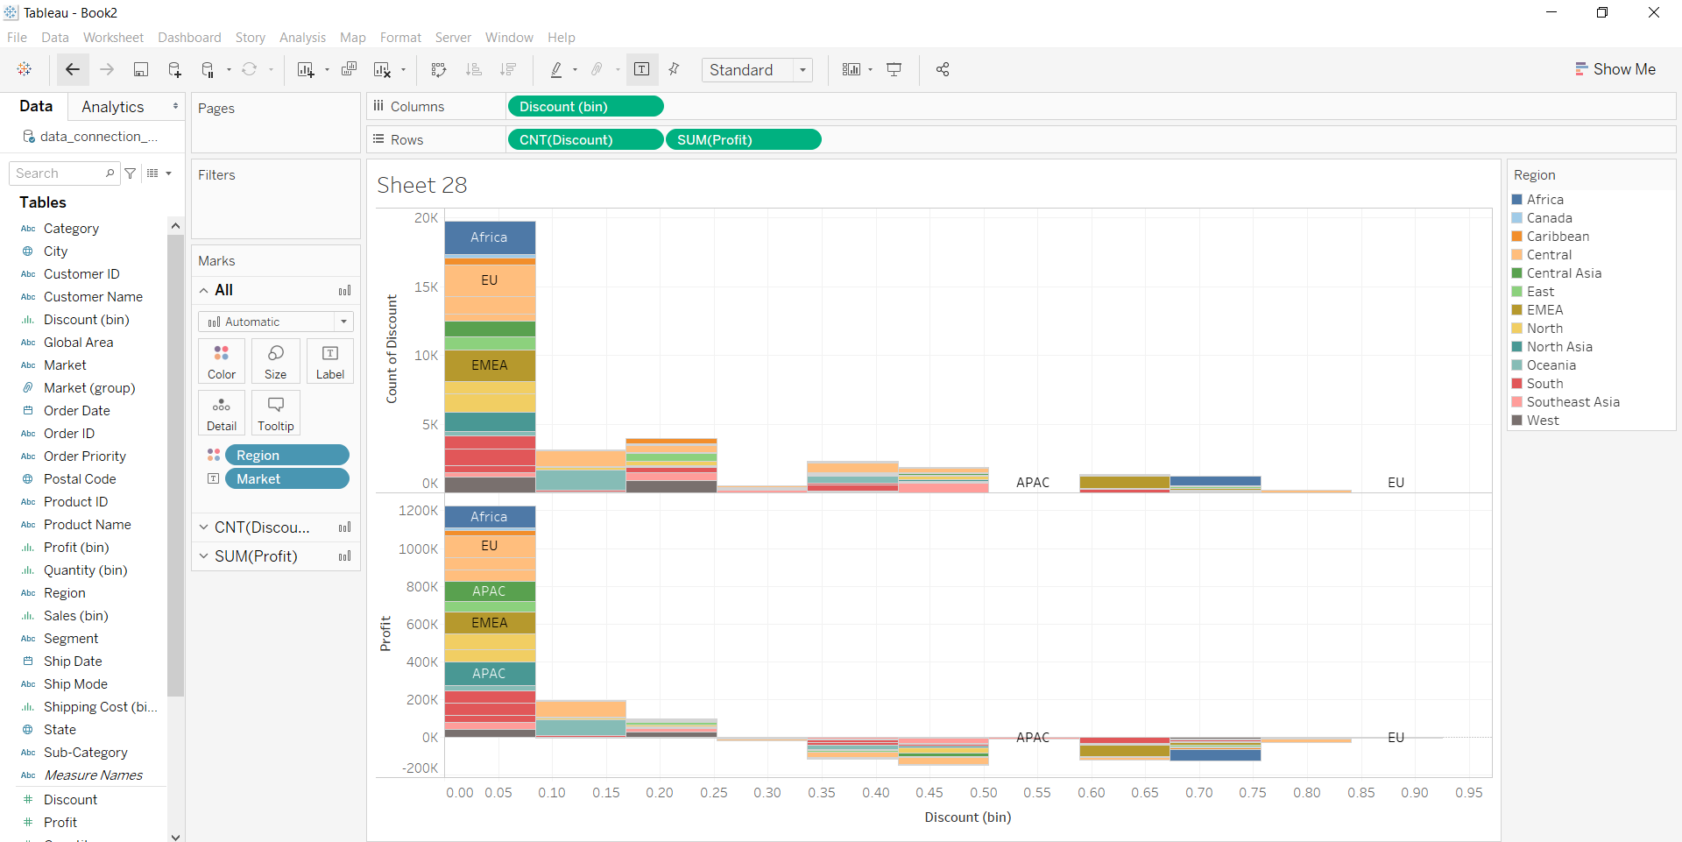



**Cumulative Histogram**: The cumulative histogram is a histogram in which the vertical axis gives not just the counts for a single bin, but rather gives the counts for that bin plus all bins for smaller values of the response variable.

For this we have to follow some steps :

Open the Tableau tool and connect a dataset to it. Drag and drop the one sheet of the connected dataset. Click on sheet1 to open the tableau worksheet. On clicking Sheet1 you will get whole dataset attributes on the left side and a worksheet for work.



To draw a cumulative histogram we have drawn a histogram with dual-axis and make it cumulative.

**Draw a histogram**



* **Add dual-axis feature**



* **Make it Cumulative with percentages**



* **Apply other marks for a better look**



**Scatter plot:**A scatter plot is a set of dotted points to represent individual pieces of data in the horizontal and vertical axis. A graph in which the values of two variables are plotted along the X-axis and Y-axis, the pattern of the resulting points reveals a correlation between them.

For this we have to follow some steps :

Open the Tableau tool and connect a dataset into it. Drag and drop the one sheet of the connected dataset. Click on sheet1 to open the tableau worksheet. On clicking Sheet1 you will get whole dataset attributes on the left side and a worksheet for work.



To draw a scatter plot, you have to select a minimum of two attributes (one in row and one in column) by drag and drop then select the chart option as scatter plot.

**Example 1:**



**Example 2:**This example is also drawn similar to above example 1 with some extra marks and which is explained in steps given below :

* Select the Discount, profit with shipping cost and Sales fields as column and row respectively.
* Select the chart type scatter plot.
* Apply marks by color of state.
* Apply marks by details of column values.
* Apply filter of column values.

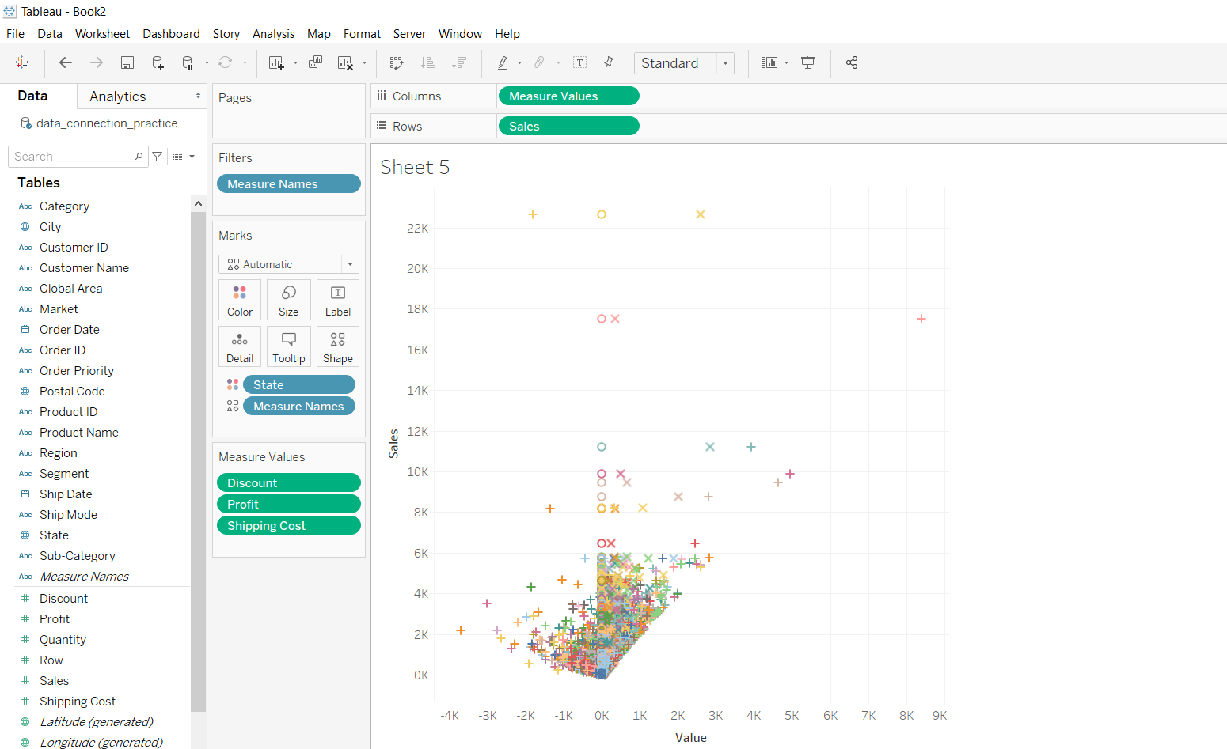

**Example 3:**This example is also drawn similar to above example 1 with some extra marks and which is explained in steps given below :

* Select the Discount with profit and Sales fields as column and row respectively.
* Select the chart type scatter plot.
* Apply marks by color of market.

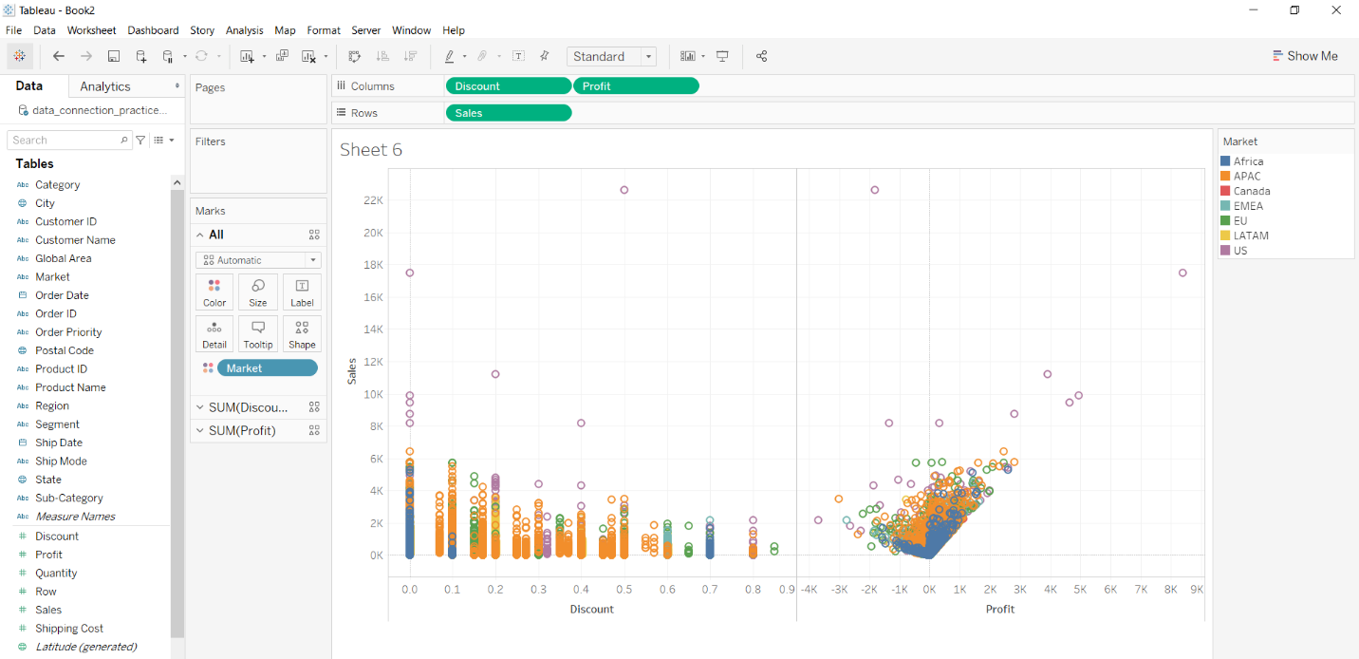

**Bubble Chart :** A bubble chart is a type of chart that displays three dimensions of data. Each entity with its triplet (v1, v2, v3) of associated data is plotted as a disk that expresses two of the vi values through the disk’s xy location and the third through its size.

For this we have to follow some steps :

* Open the Tableau tool and connect a dataset into it.
* Drag and drop the one sheet of the connected dataset.
* Click on sheet1 to open the tableau worksheet.
* On clicking Sheet1 you will get whole dataset attributes on the left side and a worksheet for work.



* To draw a bubble chart you have to select a minimum of two attributes (one in the row and one in the column) by drag and drop then select the chart option as a bubble.

**Example 1:**Bubble chart with Market as Columns and Profit as Rows.



**Example 2:**This example is also drawn similar to the above example 1 with some extra marks and which is explained in steps given below :

* Select the Region and Profit fields as column and row respectively.
* Select the chart type bubble chart
* Apply marks by labels of Discount
* Apply marks by tooltip of quantity.

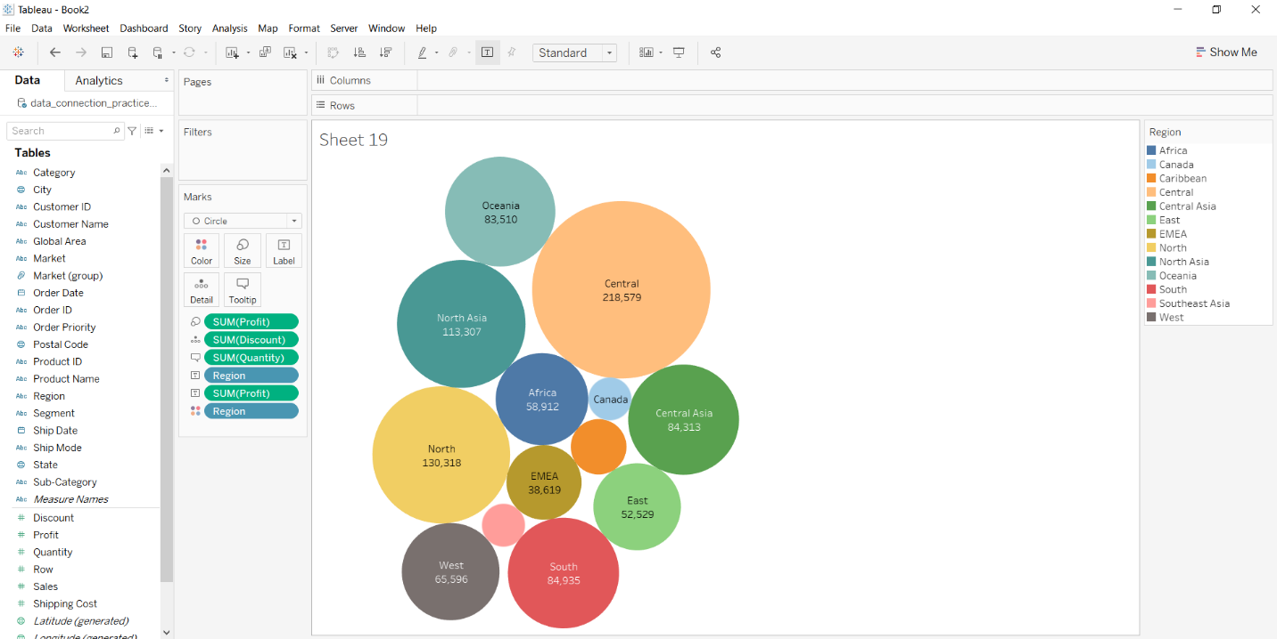

**Example 3:** This example is also drawn similar to above example 1 with some extra marks and which is explained in steps given below :

* Select the Sub category and sales fields as column and row respectively.
* Select the chart type bubble chart.
* Apply marks by labels of Category.

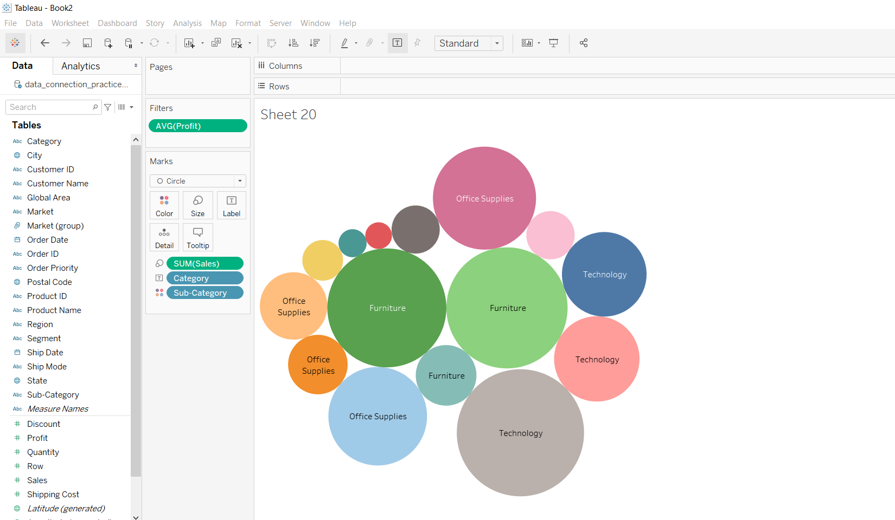

**Pie chart in tableau**

A pie chart (or a circle chart) may be a circular statistical graphic, which is split into slices, for instance, numerical proportion. In a pie chart, the arc length of every slice (and consequently its central angle and area), is proportional to the number it represents.

For this we have to import the data into tableau by following the steps below :

1. Open Tableau tool and connect a dataset into it.
2. Drag and drop the one sheet of the connected dataset.
3. Click on sheet1 to open the tableau worksheet.
4. On clicking Sheet1 you will get whole dataset attributes on the left side and a worksheet for work.



**To draw a pie chart you have to select minimum two attributes( one in row and one in column) by drag and drop then select the chart option as pie.**

**Example 1:**

In this example we draw a pie chart by following simple steps :

* Drag and drop two fields one for row and another for column.
* Click on show me and select the pie chart
* Increase the size of the pie chart by using size marks and select and drag.



**Example 2:**

* Drag and drop the Profit field into the label marks to show the labels.
* Click on Color
* Change the color by choosing the new color palette.



**Example 3:**

* Drag and drop the Sales field and then Region field into the label marks to show the labels.
* Click on Color
* Change the border color by choosing the other colors.

**Crosstab :** A crosstab is a table showing the relationship between two or more variables. Where the table only shows the relationship between two categorical variables, a crosstab is also known as a contingency table.

**Below are the steps to create a Crosstab in tableau:**

**1)**Open Tableau tool and connect a dataset into it.



**2)**Drag and drop the one sheet of connected dataset.



**3)**Click on sheet1 to open the tableau worksheet.



**4)**On clicking Sheet1 you will get whole dataset attributes on left side and a worksheet for work.



**5)**To draw a crosstab you have to select minimum two attributes( one in row and one in column) by drag and drop then select another attribute for mark option.



**Below are some examples of the above approach:**

**Example 1:**

This example is drawn similar to the above steps with some extra marks and which is explained in steps given below :

* Select the Date and Sub-category fields as column and row respectively.
* Apply marks by color of profit.
* Apply marks by text of sales.

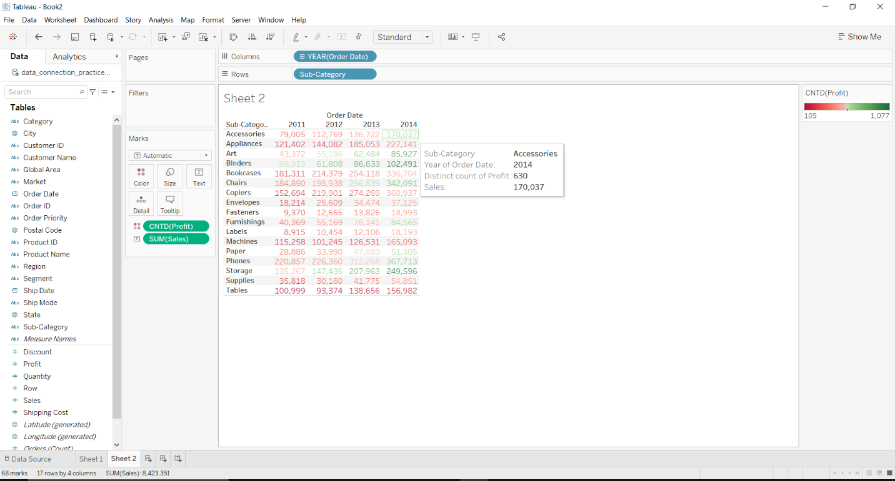

**Example 2:**

This example is also drawn similar to above example 1 with some extra marks and which is explained in steps given below :

* Select the Date and Category with Sub-category fields as column and row respectively.
* Apply marks by color of profit.
* Apply marks by text of sales.

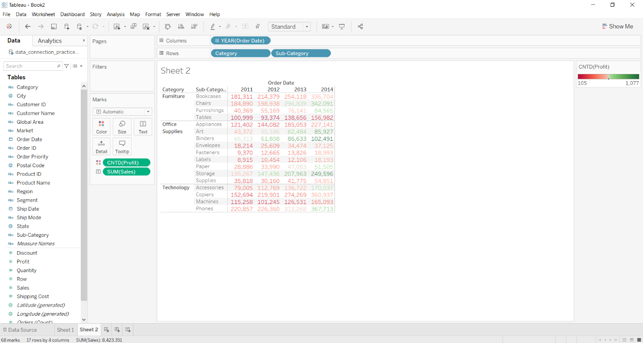

**Total in a crosstab by column**

For this we have to follow some steps :

Open the Tableau tool and connect a dataset into it. Drag and drop the one sheet of the connected dataset. Click on sheet1 to open the tableau worksheet. On clicking Sheet1 you will get whole dataset attributes on the left side and a worksheet for work



To calculate total you have to cross tab by drag and drop ans select the chart option as crosstab.

**Example 1:**In this example, we add all subtotals.



**Example 2:**In this example, we calculated the grand total of columns.



**Example 3:**In this example we remove all subtotals.



**Example 4:**In this example, we add all subtotals and change the function used for the total.



**Example 5:**In this example, we add all subtotals then arrange the total at the top.



**Box Plot:**It is the visual representation of the depicting groups of numerical data through their quartiles. Boxplot is also used for detecting the outlier in the data set. It captures the summary of the data efficiently with a simple box and whiskers and allows us to compare easily across groups.

For this we have to follow some steps :

Open the Tableau tool and connect a dataset into it. Drag and drop the one sheet of the connected dataset. Click on sheet1 to open the tableau worksheet. On clicking Sheet1 you will get whole dataset attributes on the left side and a worksheet for work.



To draw a Box Plot you have to select a minimum of three attributes (one in row, one in column and one for view) by drag and drop then select the chart option as box plot.

**Example 1 :**



**Example 2:**This example is also drawn similar to above example 1 with some extra marks and which is explained in steps given below :

* Select the Category with sub-category and profit fields as column and row respectively.
* Select the chart type box plot.
* Apply marks by color of market.

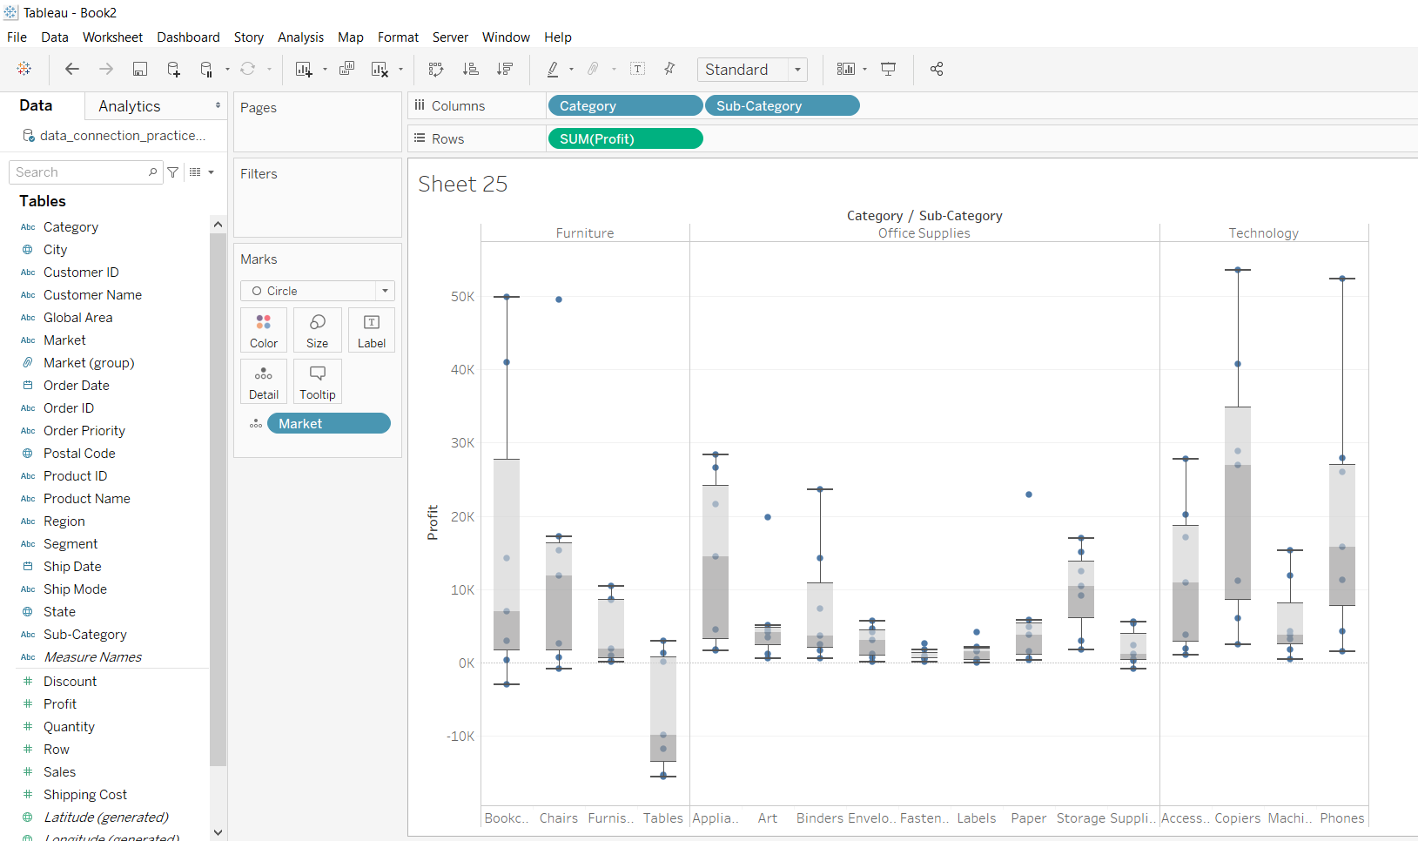

**Example 3:** This example is also drawn similar to above example 1 with some extra marks and which is explained in steps given below:

* Select the Region and Discount with profit fields as column and row respectively.
* Select the chart type box plot.
* Apply marks by color of sub-category.
* Apply marks by text of sales.

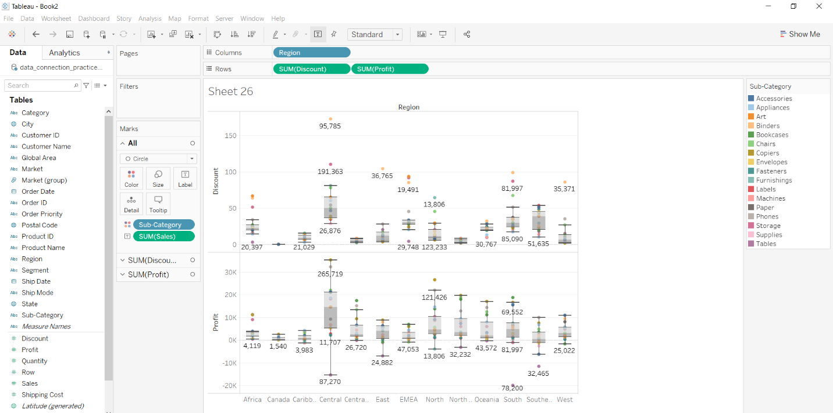

**Bullet Graph:** A bullet graph is a variation of a bar graph developed by Stephen Few. Seemingly inspired by the traditional thermometer charts and progress bars found in many dashboards, the bullet graph serves as a replacement for dashboard gauges and meters.

**For this we have to follow some steps:**

* Open the Tableau tool and connect a dataset into it.
* Drag and drop the one sheet of the connected dataset.
* Click on sheet1 to open the tableau worksheet.
* On clicking Sheet1 you will get whole dataset attributes on the left side and a worksheet for work.



* To draw a bullet graph you have to select a minimum of three attributes (two in the row and one in the column) by drag and drop then select the chart option as a bullet.

**Example 1:**Market as the column and Sales and Profit as the rows.



**Example 2:**This example is also drawn similar to above example 1 with some extra marks and which is explained in steps given below :

* Select the Region and Sales fields as column and row respectively.
* Select the chart type bullet graph.
* Apply marks by color of profit.
* Apply marks by details of shipping mode.

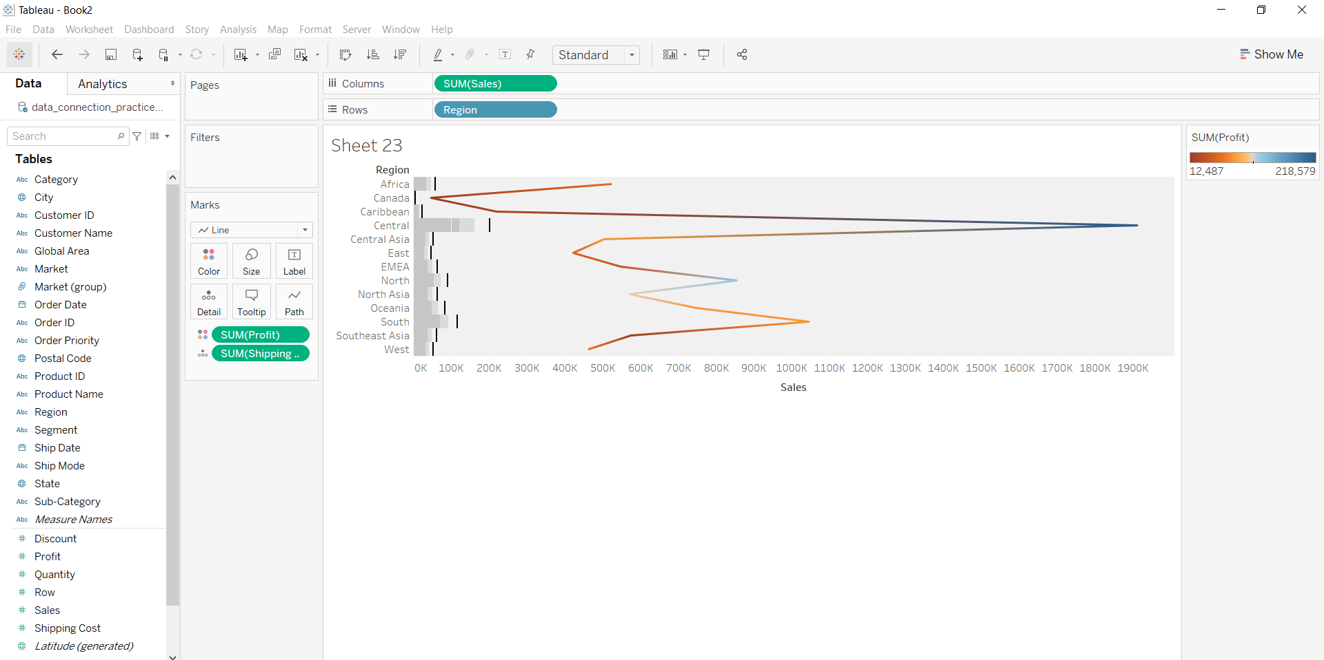

**Example 3:**This example is also drawn similar to above example 1 with some extra marks and which is explained in steps given below :

* Select the Category, Sub-Category and Profit fields as column and row respectively.
* Select the chart type bullet graph.
* Apply marks by color of discount.
* Apply marks by details of sales.

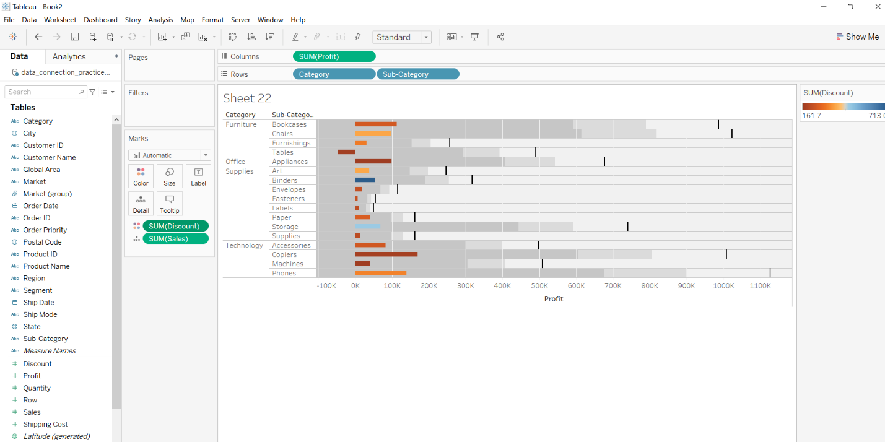

**Area charts in Tableau**

An area chart represents the change in one or more quantities over time. It is made by plotting a series of data points over time, connecting those data points with line segments, and then filling in the area between the line and the x-axis with color or shading.

 For this, we have to open the worksheet first. Follow the steps below and open the worksheet :

1. Open Tableau tool and connect a dataset into it.
2. Drag and drop the one sheet of the connected dataset.
3. Click on sheet1 to open the tableau worksheet.
4. On clicking Sheet1 you will get whole dataset attributes on the left side and a worksheet for work.



To draw an area chart you have to select minimum two attributes( one in row and one in column) by dragging and dropping. Then select the chart option as **Area**.

**Example 1:**



**Example 2:**

* Select the **Order Date** and **profit** fields as column and row respectively.
* Select the chart type area chart.
* Apply marks by color of **Subcategory**. (Drag and drop Subcategory on color in marks section)

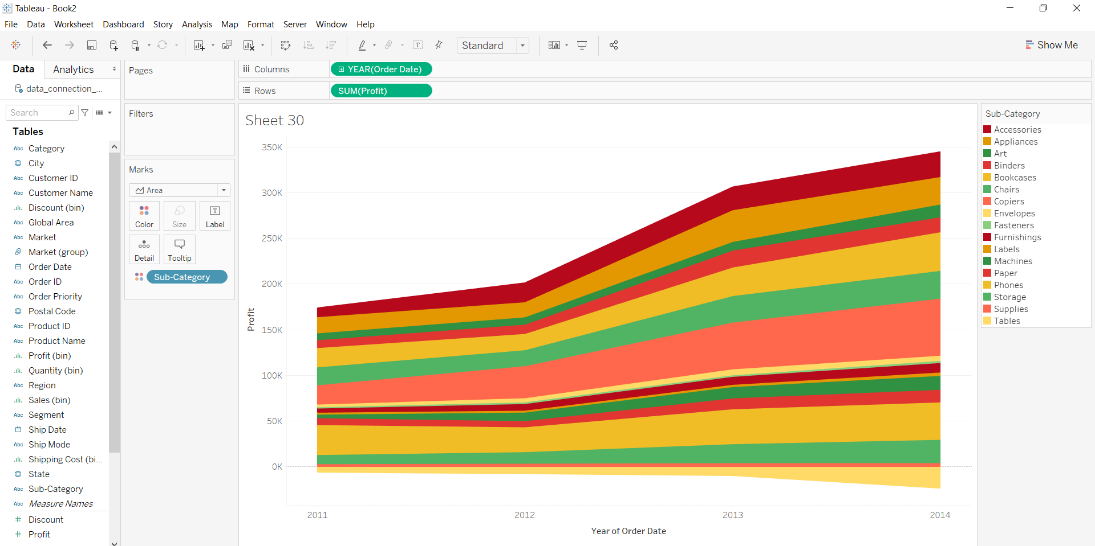

**Example 3:**

* Select the **Order Date** and **profit**  with discount fields as column and row respectively.
* In columns, drag and drop Order Date three times, so that it can be divided into yearly first, each year is divided into quarterly results and each quarter is divided into monthly result.
* Select the chart type as area chart.
* Apply marks by color of **Market**. (Drag and drop Market on color in marks section)

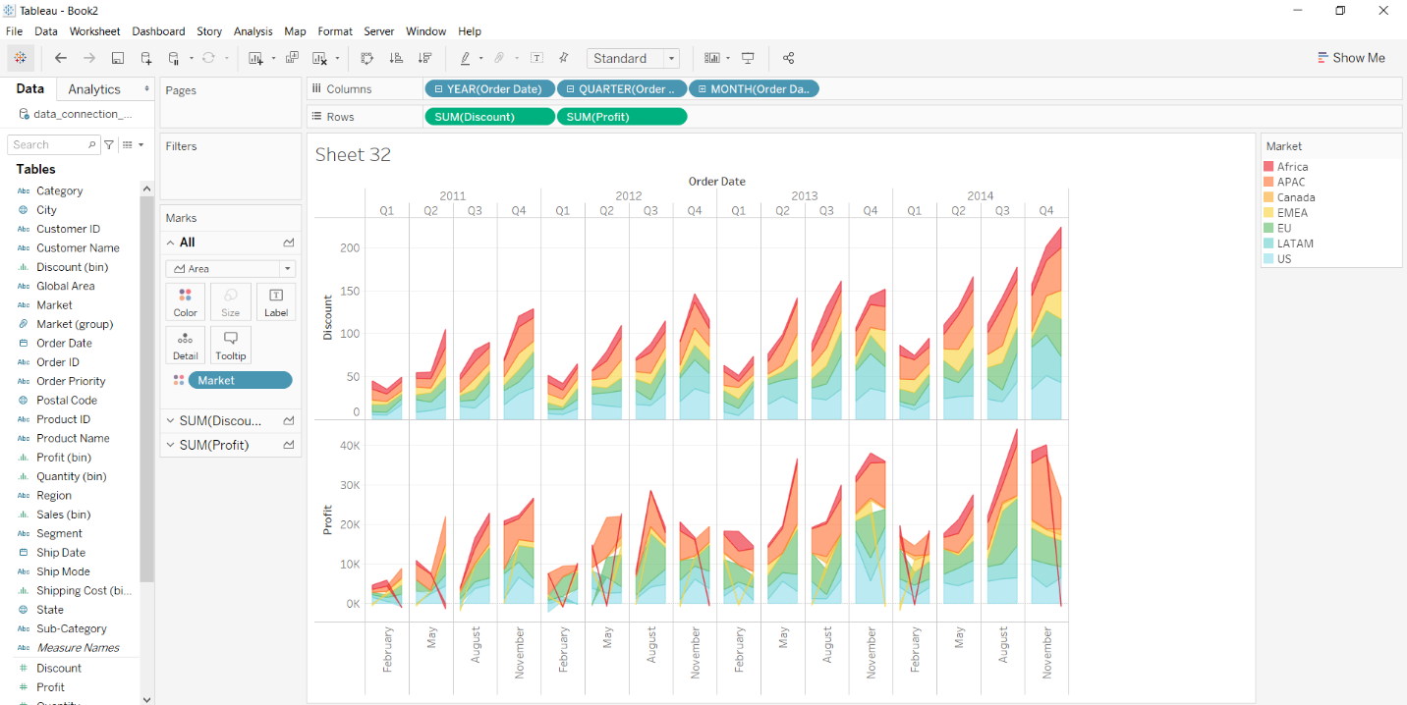

**Heat Map:**Heatmap is defined as a graphical representation of data using colors to visualize the value of the matrix. In this to represent more common values or higher activities brighter colors basically reddish colors are used and to less common or activity values darker colors are preferred. Heatmap is also defined by the name of the shading matrix.

For this we have to follow some steps :

Open the Tableau tool and connect a dataset into it. Drag and drop the one sheet of the connected dataset. Click on sheet1 to open the tableau worksheet. On clicking Sheet1 you will get whole dataset attributes on the left side and a worksheet for work.



To draw a heat map you have to select a minimum of two attributes( one in the row and one in the column) by drag and drop then select the chart option as a heat map.

**Example 1 :**



**Example 2:**This example is also drawn similar to above example 1 with some extra marks and which is explained in steps given below :

* Select the Ship mode and Subcategory as column and row respectively.
* Select the chart type heat map.
* Apply marks by color of sales.

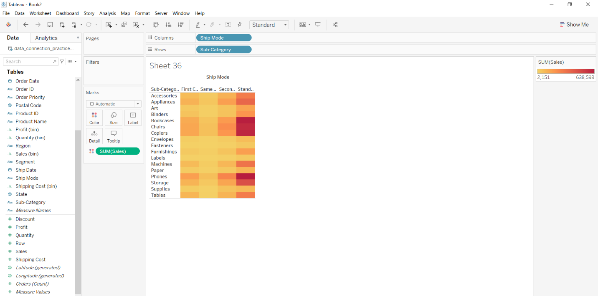

**Example 3:**This example is also drawn similar to above example 1 with some extra marks and which is explained in steps given below :

* Select the Subcategory and Market with Ship mode as column and row respectively.
* Select the chart type heat map.
* Apply marks by color of profit.

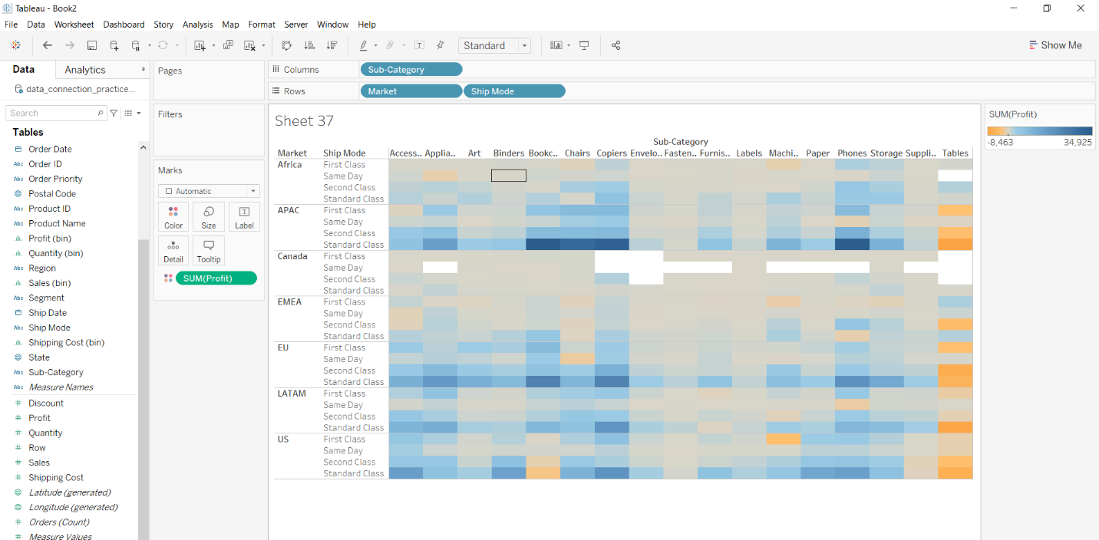

**Map:**Map visualization is employed to research and display the geographically related data and present it within the sort of maps. This kind of data expression is clearer and more intuitive. We can visually see the distribution or proportion of knowledge in each region. It is convenient for everybody to mine deeper information and make better decisions.

For this we have to follow some steps :

Open the Tableau tool and connect a dataset to it. Drag and drop the one sheet of the connected dataset. Click on sheet1 to open the tableau worksheet. On clicking Sheet1 you will get whole dataset attributes on the left side and a worksheet for work.



To draw a basic map you have to select a minimum of one attribute (a web attribute) by drag and drop then select the chart option as Map.

**Example 1:**This example will help you to draw a basic map in tableau. Here we take a web/geographical attribute and use it then apply the map by using the Show Me Option.



**Example 2:**This example is also drawn similar to the above example 1. Here we take a web/geographical attribute with a measured attribute then apply map by using the Show Me Option and by using marks of graph selection.



**Example 3:**This example is also drawn similar to above example 1 but drawn with different values and different features for better understandings.



**Geographical Plot:** Plot in Geographic Coordinates. If you have data that is associated with specific geographic locations, use geographic axes or charts to visualize your data on a map and provide visual context.

For this we have to follow some steps :

Open the Tableau tool and connect a dataset into it. Drag and drop the one sheet of the connected dataset. Click on sheet1 to open the tableau worksheet. On clicking Sheet1 you will get whole dataset attributes on the left side and a worksheet for work.



To draw a geographical map you have to select a minimum of two attributes (one in row and one in column) by drag and drop then select the chart option as map.

**Example 1 :**



**Example 2:** This example is also drawn similar to above example 1 with some extra marks and which is explained in steps given below:

* Select the State and Sales fields as column and row respectively.
* Select the chart type map.
* Apply marks by map fill.

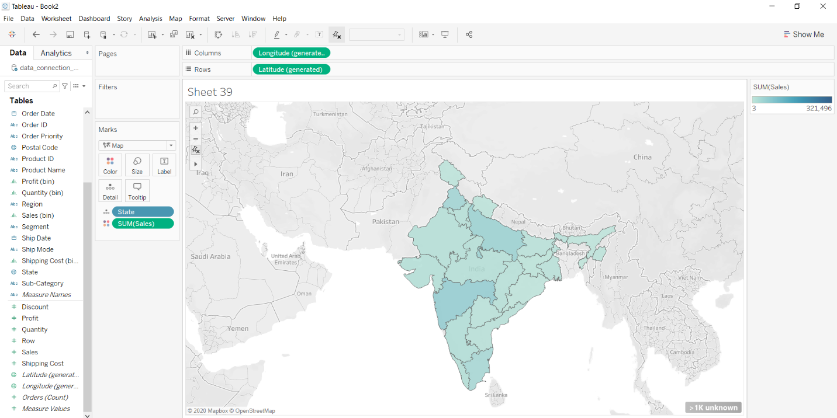

**Example 3:**This example is also drawn similar to above example 1 with some extra marks and which is explained in steps given below :

* Select the State and Profit as column and row respectively.
* Select the chart type map.
* Apply marks by color of shipping mode.
* Apply marks by text of discount.

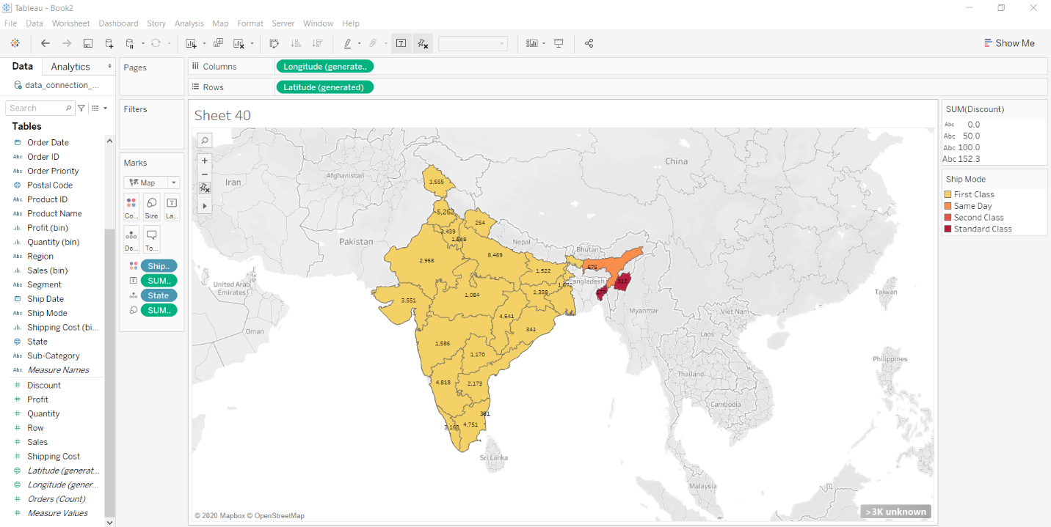

**Lollipop Chart:**The lollipop chart could also be a composite chart with bars and circles. It’s a variant of the bar graph with a circle at the top, to spotlight the info value. sort of a bar graph, a lollipop chart is employed to match categorical data.

For this we have to follow some steps :

Open the Tableau tool and connect a dataset into it. Drag and drop the one sheet of the connected dataset. Click on sheet1 to open the tableau worksheet. On clicking Sheet1 you will get whole dataset attributes on the left side and a worksheet for work.



To draw a lollipop chart you have to select a minimum of three attributes (one in a row and two in columns with dual-axis) by drag and drop then select the chart option as bar in one axis and then apply dot on another axis.

**Example 1:**In this example, we simply choose three attributes as described above and create a lollipop chart.



**Example 2:**This example uses above example 1 with some extra marks (change the size and color of lollipops) and which are shown easily below :



**Example 3:**This example uses above example 1 with some extra marks (change the shapes of lollipops) and which are shown easily below :



**Circle views in tableau**

The circle view is another powerful visualization for comparative analysis. It is just like the scatter plot with the circle marker. Here, every mark is of shape circle and can be used for further operations.

For this we have to import the dataset first. Follow the steps below.

1. Open Tableau tool and connect a dataset into it.
2. Drag and drop the one sheet of the connected dataset.
3. Click on sheet1 to open the tableau worksheet.
4. On clicking Sheet1 you will get whole dataset attributes on the left side and a worksheet for work.



To draw circle view you have to select minimum two attributes( one in row and one in column) by dragging and dropping then select the chart option as circle views.

**Example 1:**

You can use the following steps to draw a circle view.

* Drag and drop the fields in rows and columns.
* Choose the chart as circle views.



**Example 2:**

In this example, we use example 1 with some enhancements that are listed below :

* Drag and drop the fields in rows and columns.
* Choose the chart as circle views.
* Add some more fields to create multiple circle views in one.
* Use Date expanded form to create multiple circle views in one.



**Example 3:**

In this example, we use example 2 with some enhancements that are listed below :

* Drag and drop the fields in rows and columns.
* Choose the chart as circle views.
* Add some more fields to create multiple circle views in one.
* Use Date expanded form to create multiple circle views in one.
* Apply the color marks by choosing a color.
* Apply Label, Color and Label with quick table calculation on field one by one.



**Dual Combination Chart:** Combination charts are views that use multiple mark types within an equivalent visualization.

For this we have to follow some steps :

Open the Tableau tool and connect a dataset to it. Drag and drop the one sheet of the connected dataset. Click on sheet1 to open the tableau worksheet. On clicking Sheet1 you will get whole dataset attributes on the left side and a worksheet for work.



To draw a dual combination chart you have to select a minimum of three attributes (one date and another two measured values) by drag and drop into a row then apply the other parameters for better visualization.

**Example 1:**In this example, we simply draw a dual combination chart by using the show me option.



**Example 2:**This example uses above example 1 with some extra marks (apply the label, color, and different graph marks) and which are shown easily below :



**Example 3:**This example uses above example 1 with some extra marks (apply the concept of hierarchy, label, color and graph marks) and which are shown easily below :



**Treemap:** Treemap is a form of a chart with rectangles. Here the division of field is shown in the form of rectangles with respect to the value of that field. The whole view part is divided into small rectangles according to the percentage value just like a pie chart.

For this we have to follow some steps :

Open the Tableau tool and connect a dataset into it. Drag and drop the one sheet of the connected dataset. Click on sheet1 to open the tableau worksheet. On clicking Sheet1 you will get whole dataset attributes on the left side and a worksheet for work.



To draw a treemap you have to select a minimum of two attributes (one in the row and one in the column) by drag and drop then select the chart option as a treemap.

**Example 1:**In this example, you can use the following steps to draw a treemap.

* Drag and drop the date field in column and Ship Mode field in row.
* Apply marks by color of discount field.
* Choose the chart as tree map.



**Example 2:**In this example, you can use the following steps to draw a treemap.

* Drag and drop the date field in column and market field in row.
* Apply marks by color of sales field.
* Choose the chart as treemap.
* The use the concept of hierarchy and its expanded form.



**Example 3:**In this example, you can use the following steps to draw a treemap.

* Drag and drop the Category with Sub-category field in column and Region field in row.
* Apply marks by color of profit field.
* Choose the chart as treemap.
* Apply marks by the label of profit.



**Funnel Chart:** The Funnel chart is employed to see the progressive reduction of knowledge because it passes from one phase to a different phase. Data in each of those phases is represented as different portions of 100% (the whole). Like the chart, the Funnel chart doesn’t use any axes either. Each stage of the funnel represents a neighborhood of the entire. Therefore, it assumes the form of a funnel — with the primary stage being wide and therefore the largest, and every subsequent stage smaller than its previous stage.

**Steps to illustrate Funnel Chart in Tableau:**

**1.**Open Tableau tool and connect a dataset into it.

**2.**Drag and drop the one sheet of connected dataset.

**3.**Click on *Sheet1* to open the tableau worksheet.

**4.**On clicking *Sheet1* you will get whole dataset attributes on left side and a worksheet for work.



**5.**To draw a funnel chart you have to select minimum one attributes by drag and drop into row then apply the            another parameters for better visualization.

**Example 1:**

Here, we simply draw a funnel chart and apply an attribute by size on it.



**Example 2:**

This example uses above example 1 with some extra marks (apply the label and color marks) and which are shown below:



**Example 3:**

This example is similar to example 1 but applied on different values with different features with more clarification of whole procedure.



**Traditional Funnel Chart:** A traditional funnel chart does not follow data visualization best practices, and a horizontal bar chart displaying the same data is one easier-to-read alternative.

**Steps to illustrate a Traditional Funnel Chart in Tableau:**

**1.**Open Tableau tool and connect a dataset into it.

**2.**Drag and drop the one sheet of connected dataset.

**3.**Click on *Sheet1* to open the tableau worksheet.

**4.**On clicking *Sheet1* you will get whole dataset attributes on left side and a worksheet for work.



**5.**To draw a traditional funnel chart you have to select minimum two attributes (one and another with negative            value of first) by drag and drop into row then apply the another parameters for better visualization.

Let’s draw a Traditional Funnel chart by following some steps :

* Draw a simple area chart with descending order



* Add a newly created field with negative values of measured parameter used in above area chart



* Add some marks by label, color, etc for better look (optional)



**Waterfall Chart:** The cumulative histogram is a histogram in which the vertical axis gives not just the counts for a single bin, but rather gives the counts for that bin plus all bins for smaller values of the response variable.

**Steps to illustrate a Waterfall Chart in Tableau:**

**1.**Open Tableau tool and connect a dataset into it.

**2.**Drag and drop the one sheet of connected dataset.

**3.**Click on *Sheet1* to open the tableau worksheet.

**4.**On clicking *Sheet1* you will get whole dataset attributes on left side and a worksheet for work.



**5.**To draw a waterfall chart we have draw a bar chart, convert to Gantt Chart, form negative axis and apply it to            make chart like waterfall.

* Draw a Bar Chart



* Make it running and convert to Gantt Chart



* Form a negative valued new field and apply on size



* Apply other marks for better look (optional)



**Gantt Chart:** A Gantt chart, commonly utilized in project management, is one among the foremost popular and useful ways of showing activities (tasks or events) displayed against the clock. On the left of the chart may be a list of the activities and along the highest may be a suitable duration. Each activity is represented by a bar; the position and length of the bar reflects the beginning date, duration and end date of the activity.

**Steps to illustrate a Gantt Chart in Tableau:**

**1.**Open Tableau tool and connect a dataset into it.

**2.**Drag and drop the one sheet of connected dataset.

**3.**Click on *Sheet1* to open the tableau worksheet.

**4.**On clicking *Sheet1* you will get whole dataset attributes on left side and a worksheet for work.



**5.**To draw a Gantt chart you have to select minimum two attributes (one date attribute and one dimensions                  attribute) by drag and drop then select the chart option as Gantt.

**Example 1:**

This example will help you to draw a simple Gantt Chart.



**Example 2:**

Below example is also drawn similar to the above example with some extra features of color and hierarchy.



**Example 3:**

This example is also drawn similar to above example 1 but drawn with different values and different features for better understandings.

